***Acknowledgments***

Izma Naveed

*Table of Contents*

*List of Acronyms* 5

*List of Tables* 7

*List of Figures* 8

Chapter 1 11

1 Introduction 11

1.1 Problem Statement 11

1.2 Project Objectives 11

1.3 Report Outline 12

2 Literature Review 13

2.1 fh 13

3 Methodology 14

3.1 How does Pulse Oximeter Works? 14

3.2 Working of MAX30100 Pulse Oximeter and Heart-Rate Sensor 14

3.3 Block Diagram 15

3.4 Circuit Diagram 15

3.5 Hardware Setup 15

Chapter 4 15

4 Results and Discussions 15

Chapter 5 15

5 Limitations 15

5.1 Future Work 15

Chapter 6 15

6 Conclusion 15

***List of Acronyms***

FOV ………………………………………………………………………..……………………..… Field of View

SDA …………………………………………………………………………………………………… Serial Data

SCL …………………………………………………………………………...……………………… Serial Clock

PMOD ………………………………………………….………….………………… Peripheral Module interface

FPGA ……………………………..………………………………..…………… Field Programmable Gate Array

PIR …………………………………………………….…….…………………………… Passive Infrared Sensor

UI …………………………………………………..…………………………….………………… User Interface

UX ……………………………………………….……..…………………………………………User Experience

HD ……………………………………………………………………...………………………… High Definition

DSP …………………………………………………...………………………..…………Digital Signal Processor

ASIC ………………………..…………………………………………… Application-Specific Integrated Circuit

PSNR …………………….……………….…………….……….…………………… Peak Signal-to-Noise Ratio

MTCCN ………………………….…………………………. Multi-task Cascade Convolutional Neural Network

***List of Tables***

Table 2‑1: Wired Systems Cost Comparison 5

Table 2‑2: Wireless Systems Cost Comparison 6

Table 3‑1: OV7670 camera specs 10

Table 3‑2: ESP32-CAM Specs 18

Table 3‑3: OV2640 specs 18

Table 4‑1: OV7670 FPGA (Nexys2 Board) Clock results 33

Table 4‑2: FPGA (Nexys2 Board) Device Utilization Summary 34

Table 4‑3: Access Control Implementation Cost 36

Table 4‑4: Motion Sensing Implementation Cost 36

Table 4‑5: Electric Door Lock Implementation Cost 37

Table 4‑6: Tamper Detection Implementation Cost 37

Table 4‑7: Wireless Video Door Monitoring System Features and Implementation Cost 40

***List of Figures***

Figure 3‑1: Wireless Video Door Monitoring System Working 7

Figure 3‑2 Block Diagram of Phase 1 8

Figure 3‑3: Phase 1 implementation flowchart 9

Figure 3‑4: OV7670 video streaming block diagram 10

Figure 3‑5: RGB color model 11

Figure 3‑6: VGA Connections [15] 12

Figure 3‑7: PMOD Connections [15] 12

Figure 3‑8: OV7670 Video streaming via VGA 13

Figure 3‑9: I2C master-slave connection 13

Figure 3‑10: I2C data frame 14

Figure 3‑11: I2C-like SCCB interface for communicating with the OV7670 camera [16] 15

Figure 3‑12: RGB 555 Output Timing Diagram [16] 16

Figure 3‑13: VGA display [15] 16

Figure 3‑14: ESP32 Cam Pinout [17] 17

Figure 3‑15: ESP32 CAM web server 18

Figure 3‑16: ESP32 STA Mode [18] 19

Figure 3‑17: Android App for remote video streaming 19

Figure 3‑18: Web Server access on Android App 20

Figure 3‑19: Current ESP-WHO Framework 22

Figure 3‑20: User WIFI Id and Password 22

Figure 3‑21: PIR Motion Sensor 23

Figure 3‑22: SPDT Relay [20] 23

Figure 3‑23: Inverter circuit [21] 24

Figure 3‑24: Motion Sensor Light Schematic 24

Figure 3‑25: Electric Lock Block Diagram 25

Figure 3‑26: Electric lock circuit schematic 26

Figure 3‑27: Electric Lock Flow Chart 27

Figure 3‑28: Android App Development on Android Studio 28

Figure 3‑29: (a) App Start, (b) Check App History 28

Figure 3‑30: (c) Connect to Bluetooth, (d) Allow Bluetooth access, (e) Select HC-05 29

Figure 3‑31: Tamper Detection Circuit 30

Figure 4‑1: A basic building block for OV7670 video streaming using FPGA 34

Figure 4‑2: System block diagram for Top-level module for OV7670 video streaming using FPGA 35

Figure 4‑3: ESP-32 CAM Webserver 35

Figure 4‑4: (a) Android app for remote video streaming, (b) Web server access 38

Figure 4‑5: (a) App Start Screen, (b) Check history for opening of door 39

Figure 4‑6: (c) Connect to Bluetooth, (d) Prompt to allow the connection (e) Select HC-05 39

Figure 6‑1: OV7670 Functional Block Diagram [16] 44

Figure 6‑2: OV7670 Pin definition [16] 45

Figure 6‑3: VGA (640 x 480) frame signals [16] 46

Figure 6‑4: Changing the FPS of OV7670 [16] 47

Figure 6‑5: OV7670 format registers [16] 48

Figure 6‑6: ESP32- CAM dimensions [26] 49

Figure 6‑7: Internal Pin Connect [26] 49

Figure 6‑8: ESP32-CAM product specification 50

*Abstract*

**Chapter 1**

# **Introduction**

A worldwide health emergency is declared by WHO (World Health Organization) due to the outbreak of COVID-19. There was an increase in demand for oximeters as the number of COVID-19 infected patients increased by thousands daily. Hospitals were at full capacity and unable to tend to every patient when there so many in critical condition. People started buying pulse oximeters as soon as they learned that low oxygen level can be an indicator of COVID-19.

The reasoning behind this is that shortness of breath is not easy for a person to reasonably self-assess. Doctors also reported that some COVID-19 patients develop a condition called “silent hypoxia” where people look and feel comfortable—and don’t notice any shortness of breath—but their oxygen levels are dangerously low. It happens to patients both in the hospital and at home, but it is a problem in the latter case because the symptom may indicate severe COVID-19-related pneumonia, requiring a ventilator. That’s why some people may want or need to monitor their oxygen saturation levels at home.

In the words of a Yale Medicine pulmonologist, Dr. Lutchmansingh, “It’s helpful to know your baseline level,” she says. “If there are changes, a medical professional can talk about what’s causing those changes and take any additional measures to investigate it.” [1]

## Problem Statement

Considering the COVID-19 pandemic, increase in use of oximeters and oxygen level monitoring was needed due to which demand for oximeters increased rapidly. The oximeters currently available in market are costly and not feasible for everyone.

## Project Objectives

This project supports the following objectives:

* To cater the increasing market demand in Pakistan for pulse oximeters due to COVID-19
* To develop a cost-effective model
* Make it user friendly so a layman has no problem using it

## Report Outline

Chapter 2

# **Existing Solutions**

A survey of existing models available in the market was done and compiled below:

|  |  |  |  |  |
| --- | --- | --- | --- | --- |
|  | Beurer [2] | Certeza [3] |  |  |
| Model Number | PO-30 | PO-907 |  |  |
| Battery Operated | Yes | Yes |  |  |
| Heart Rate Monitor | Yes | Yes |  |  |
| SP02 Monitor | Yes | Yes |  |  |
| Mobile App Interface | No | No |  |  |
| Price (in Rs) | 7300/- | 9500/- |  |  |

Chapter 3

# **Methodology**

## How does Pulse Oximeter Works?

Oxygen enters the lungs and then is passed on into blood. The blood carries oxygen to the various organs in our body. The main way oxygen is carried in our blood is by means of hemoglobin.

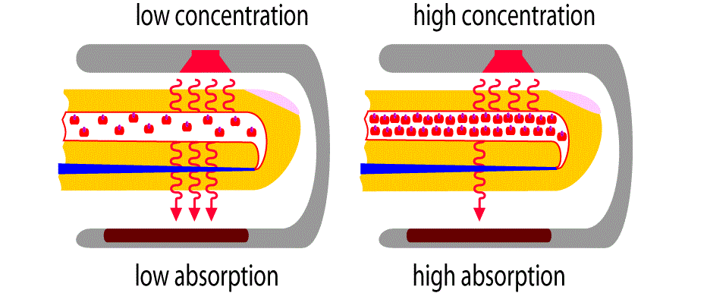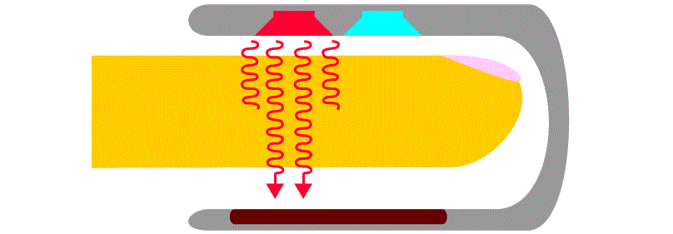

During a pulse oximetry reading, a small clamp-like device is placed on a finger, earlobe, or toe.

Small beams of light pass through the blood in the finger, measuring the amount of oxygen. It does this by measuring changes in light absorption in oxygenated or deoxygenated blood.

## MAX30100

The MAX30100 is an integrated pulse oximetry and heart-rate monitor sensor solution. It combines two LEDs, a photodetector, optimized optics, and low-noise analog signal processing to detect pulse oximetry and heart-rate signals.  
  
The MAX30100 operates from 1.8V and 3.3V power supplies and can be powered down through software with negligible standby current, permitting the power supply to remain connected at all times.

**Applications:**

* Wearable Devices
* Fitness Assistant Devices
* Medical Monitoring Devices

### Detection Principle

## OLED Display

## Working ****of MAX30100 Pulse Oximeter and Heart-Rate Sensor****

The device has two LEDs, one emitting red light, another emitting infrared light. For pulse rate, only the infrared light is needed. Both the red light and infrared light is used to measure oxygen levels in the blood.

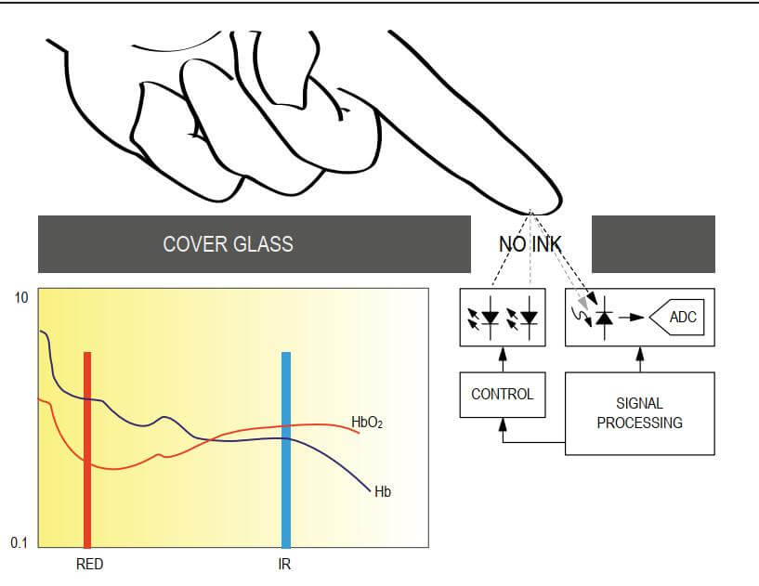

When the heart pumps blood, there is an increase in oxygenated blood as a result of having more blood. As the heart relaxes, the volume of oxygenated blood also decreases. By knowing the time between the increase and decrease of oxygenated blood, the pulse rate is determined.

It turns out, oxygenated blood absorbs more infrared light and passes more red light while deoxygenated blood absorbs red light and passes more infrared light. This is the main function of the MAX30100: it reads the absorption levels for both light sources and stored them in a buffer that can be read via I2C.

## Block Diagram

## Circuit Diagram

MAX30100 & OLED Display works on I2C Communication Protocol. So its SDA & SCL pin is connected to I2C pin of Arduino, i.e A4 & A5. Similarly Bluetooth module is an UART module and need to be connected to Tx & Rx pins of Arduino.

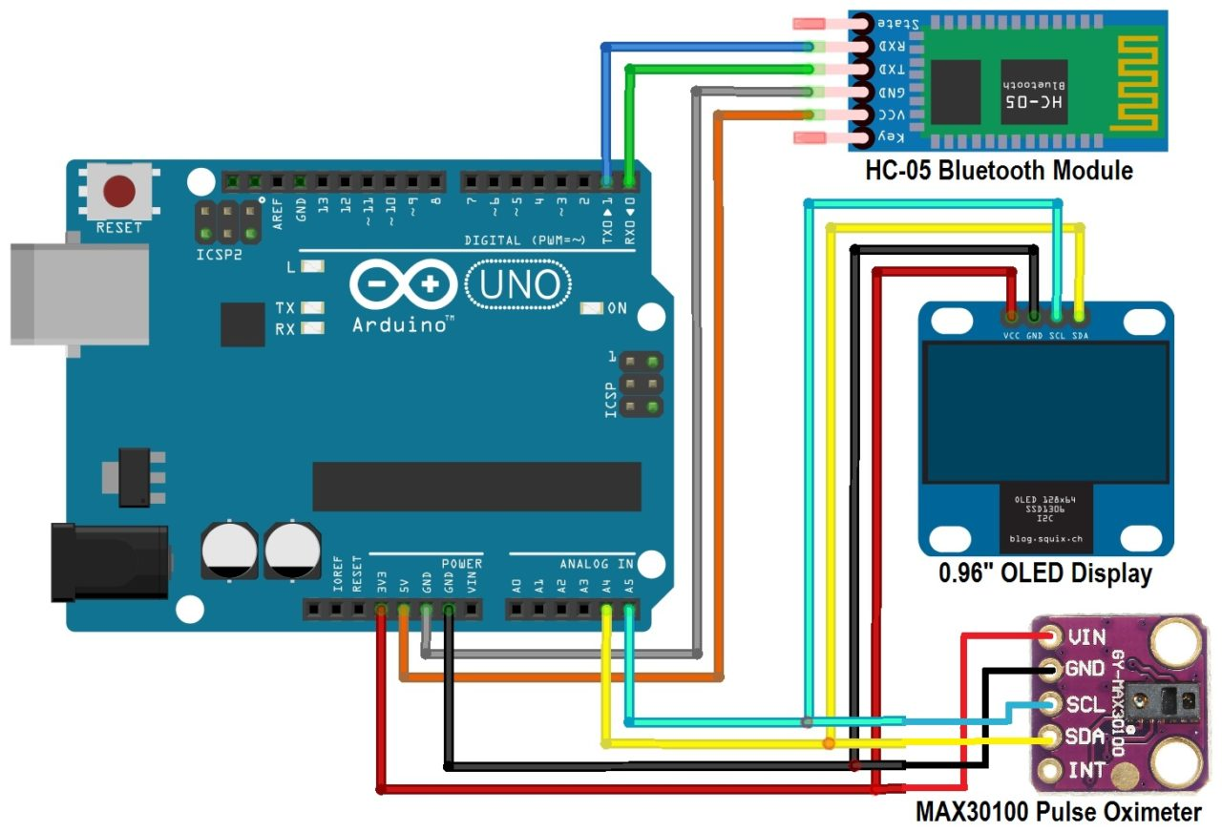

## Hardware Setup

## Arduino Serial Monitor Display

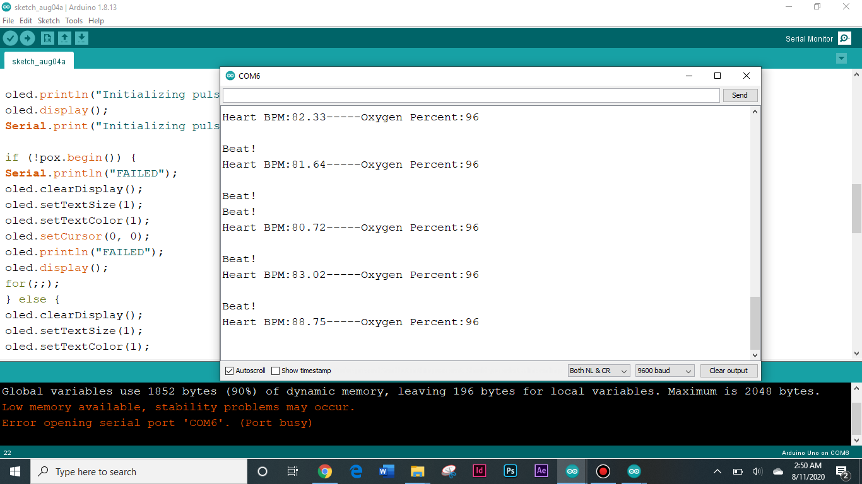

## MIT App inventor

|  |  |  |
| --- | --- | --- |
|  |  |  |

|  |  |
| --- | --- |
|  |  |

Chapter 4

# Results and Discussions

Correct usage is key to a trustworthy reading:

* Use in a rested sitting position
* Ensure the device is properly positioned on your finger
* Take into account that you may be living at altitude
* Artificial nails and nail polish, especially gel-based, can produce inaccurate measurements
* Cold hands or poor circulation can also interfere with the light and produce false numbers
* Check to see that you are not accidentally reading the numbers upside down if you are getting a strange reading

|  |  |
| --- | --- |
| Total cost | |
| **Arduino Uno** | Rs. 700 |
| **MAX 30100** | Rs. 450 |
| **OLED display 0.96”** | Rs. 250 |
| **Bluetooth module** | Rs. 450 |
| **Total Expenses** | **Rs. 2000** |

Chapter 5

# Limitations

## Future Work

Chapter 6

# Conclusion

[1] <https://www.yalemedicine.org/stories/covid-pulse-oximeter/>

[2] <https://hallroad.org/beurer-pulse-oximeter-po-30-in-pakistan.html>

[3] <https://www.ishopping.pk/certeza-pulse-oximeter-po-907-ht.html>